FOR IMMEDIATE RELEASE
Horton & Mendez Injury Attorneys Continues “Best of NC Teachers 2026” Contest to Honor North Carolina Teachers
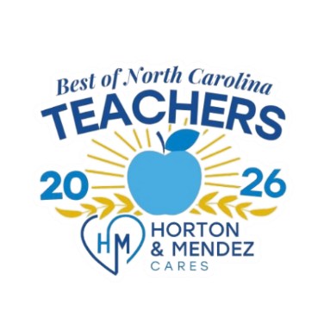
Voting Now Open – $4,000 in Prizes Available
Wilmington, NC – Following an overwhelming response to the Best of NC Teachers 2025 campaign — with over 500 nominations and votes submitted from communities across the state — Horton & Mendez Injury Attorneys is proud to announce the return of the Best of NC Teachers contest for 2026. The contest is open to teachers across the state and all public and private elementary, middle, and high schools in North Carolina are eligible to win.
Voting is officially open now through Sept 14th, 2026, at BestofNCTeachers.com, where community members can vote for their favorite local teacher. The top three winners will receive cash prizes totaling $4,000:
- 1st Place – $2,000
- 2nd Place – $1,250
- 3rd Place – $750
Winners will be announced live on Facebook at the end of September. Be sure to follow Horton & Mendez Injury Attorneys on Facebook to stay up to date and celebrate with us as we recognize these deserving individuals.
How to Participate:
1. Visit BestofNCTeachers.com
2. Vote for your favorite local teacher
3. Share the campaign with friends, family, and coworkers to spread the word

“We were blown away by the response to last year’s Best of NC Teachers campaign and the incredible stories people shared,” said Nick Mendez, founding partner of Horton & Mendez. “It was an honor to recognize so many deserving individuals, and we’re incredibly grateful to everyone who participated. We’re excited to bring the campaign back in 2026 to celebrate even more remarkable teachers across North Carolina.
This initiative is part of Horton & Mendez Cares, the firm’s charitable program that donated more than $75,000 to North Carolina nonprofits in 2025.
Media Contact:
Taylor Godbold, Marketing Manager
Horton & Mendez Injury Attorneys
6105 Oleander Dr., Suite 102, Wilmington, NC 28403
(910) 660-0223 | taylor@hortonmendez.com
www.hortonmendez.com

